

**MASENO UNIVERSITY**

**SCHOOL OF COMPUTING AND INFOMATICS**

**DEPATMENT OF COMPUTER SCIENCE**

**CCS 403: PROJECT 1**

PROJECT TITLE

**SMART FARM**

ANIDA KIMTAI KIRUI CCS/00012/020

A project submitted to the Department of Computer Science in the School of Computing and Informatics Technology. In partial fulfilment of the requirements for the award of degree of BSc Computer Science Maseno University

# **DECLARATION**

The Project is my original work and has not been presented for a degree in any other university.

Name: .................................................................

Reg. Number: ......................................................

Signature: ...........................................................

Date: ...................................................................

This project has been submitted for examination with my approval as University Supervisor.

Name: ...................................................................

Signature: .............................................................

Date: .....................................................................

Maseno, Kenya

# **DEDICATION**

Thanks to Allah, the most Merciful and the most Gracious. Special thanks to My supervisor, Dr James Obuhuma for his professional guidance and support in academic and in real life. I’m greatly indebted for his patience and invaluable advices that inspired me to see things positively and felt honoured with his confidence and trust on my own ability. Last but not least, not forgetting those who have directly or indirectly helped me on this project. May Allah rewards your kindness in abundance in this world and next.

# **ACKNOWLEDGEMENT**

It is always a great relief when you done with something you have been working on for a long time. It is the same when you complete your final project. Unlike other assignment, a project is successfully completed with the mental moral guidance of your mentor, friends, course mates, family and generally the whole school department.

I would like to express me special thanks to my mentor and guide through the start of the project Dr James Obuhuma for his time, effort and dedication in providing me with the right and most appreciated guideline in all effort to ensure I have a smooth and easy task in doing this project. Your useful advice was really helpful to me during the project completion. In this aspect, I am eternally grateful to you.

More and more special thanks to the school of computing (computer science) department for all the help they have provide either directly or indirectly. Special thanks to our school dean and the head of our department for the provision of the school WI FI and our helpful lecturers they have been helpful throughout. I take this chance to eternally thank you and all the department staff for all their help. I say “Shukran Dr”.

# **ABSTRACT**

The "Smart Farm" project is a forward-looking initiative that addresses the inefficiencies of traditional farming by focusing on five core objectives. It aims to optimize water resource management, enhance livestock health, minimize labour costs, enable remote monitoring, and improve product preservation techniques. While promising, the project relies on assumptions like farmer technology adoption and resource availability, and it faces limitations such as initial investments, maintenance, and user adoption. In the pursuit of our objectives, this literature review delves into the core components of the "Smart Farm" project. It examines manual sprinkler irrigation (Van_der_Gulik & Tedbranch. 1989)., Cold Room (Cold Storage Chamber) (Duret, Hoang, Flick, & Laguerre ,2014), Cow Hand Feeding (Jago, Krohn, & Matthews 1999), Cattle Sprayer (Knapp, Henso, Panchappa, & Yeoman, 1989), and Tank Refilling Pump (Knapp, Henso, Panchappa, & Yeoman, 1989), elucidating their features, advantages, and limitations. By scrutinizing these agricultural practices, aim to offer insights into their relevance and effectiveness by improving every weakness of the system. The project's technological framework, emphasizing the fusion of computer science with agriculture's core objectives. These objectives, which encompass efficient water resource management, enhanced livestock health and hygiene, reduced labour costs, remote monitoring, and improved product preservation, are systematically tackled through the strategic deployment of technology and system design. This section underscores the transformative power of well-planned computer-based solutions, encompassing data analytics, automation, and remote monitoring tools, to revolutionize agricultural practices. The meticulous design and analysis of these systems are central to achieving the project's overarching goals, contributing to more sustainable, productive, and profitable farming operations.

Contents

**DECLARATION** i

**DEDICATION** ii

**ACKNOWLEDGEMENT** iii

**ABSTRACT** iv

**List of Figures** vi

**List of Tables** vii

**Abbreviation** viii

**Definition of Terms** ix

**CHAPTER 1** 1

**INTRODUCTION** 1

**1.1 Background of Study** 1

**1.2 Problem Statement** 2

**1.3 Research Objective** 3

**1.3.1 General Objective** 3

**1.3.2 Specific Objectives** 3

**1.4 Research Questions** 4

**1.5 Justification** 4

**1.6 Scope of Study** 5

**1.7 Assumption and limitation** 6

**1.7.1 Assumptions** 6

**1.7.2 Limitations:** 6

**1.8 Significance of the project.** 7

**1.9 Summary** 8

**CHAPTER 2** 9

**LITRETURE REVIEW** 9

**2.1 Introduction** 9

**2.2 Manual Sprinkler Irrigation** 9

**2.3 Cold Room (Cold Storage Chamber)** 10

**2.4 Cow Hand Feeding** 12

**2.5 Cattle Sprayer** 13

**2.6 Tank Refilling Pump** 14

**2.7 The Research Gap** 15

**2.8 Summary** 18

**CHAPTER 3** 19

**SYSTEM ANAYSIS AND DESIGN** 19

**3.1 Introduction** 19

**3.2 Methodology** 19

**3.2.1 Data Collection Tool and Techniques** 19

**3.2.2 Data Analysis Tool and Techniques** 19

**3.3 System Analysis** 20

**3.3.1 User and System Requirements** 20

**3.3.2 Functional Requirements** 21

**3.3.3 Nonfunctional Requirements** 21

**3.4 System Design** 22

**3.4.1 System Architecture** 22

**3.4.2 User Case Diagram** 23

**3.4.3 Context Diagram** 24

**3.4.4 Data Flow Diagram** 25

**3.3.5 Class Diagram** 28

**3.4.6 Entity Relationship Diagram** 29

**3.5 Work Plan** 29

**3.6 Budget** 30

**3.7 Summary** 30

**Reference** 30

**Appendix** 31

**3.2 farm operations** 31

**3.2 Questionnaire results** 32

**3.5 Gantt Chart** 33

**3.6 Budget** 34

# **List of Figures**

Figure 3.0.1 21

Figure 3.0.2 21

Figure 3.0.3 22

Figure 3.0.4 23

Figure 3.0.5 24

Figure 3.0.6 25

Figure 3.0.7 26

Figure 3.0.8 27

Figure 3.0.9 28

Figure 3.0.10 30

Figure 3.0.10.2 31

Figure 3.0.10.3 32

# **List of Tables**

Table 1 15

Table 2 33

# **Abbreviation**

AC – Air Conditioner

Mobile APP – Mobile Application

# **Definition of Terms**

**Air conditioner** - is a device that controls the temperature, humidity, and cleanliness of air in an enclosed space. It cools the air by removing heat and is commonly used in buildings and vehicles to provide comfort.

**Automated cow spray**- is a system using technology to apply protective or therapeutic substances to cows, enhancing their well-being or addressing specific needs, often triggered by sensors or programmable settings.

**Cold room -** is a refrigerated storage space designed to maintain low temperatures for preserving and storing perishable items such as food, pharmaceuticals, or other temperature-sensitive products.

**Automated farm irrigation**- refers to a system utilizing technology to autonomously control and optimize the watering of crops, efficiently delivering the right amount of water at precise intervals, often based on sensor data, weather conditions, or programmed schedules.

**Automated tank water systems**- involve the use of technology to control and manage the storage, distribution, and utilization of water in tanks, often incorporating sensors, pumps, and automated controls for efficient and hands-free operation.

# **CHAPTER 1**

# **INTRODUCTION**

## **1.1 Background of Study**

In recent years, agriculture has undergone a significant transformation, driven by advancements in technology and the need for more efficient and sustainable farming practices. The "Smart Farm" project is a response to the evolving challenges faced by modern agriculture, where traditional methods often fall short in meeting the demands of a growing global population, ensuring food security, and managing resources responsibly. This background of study will explore the context and motivation behind the development of the five key modules that constitute the Smart Farm project.

The world's population is steadily increasing, putting greater pressure on agricultural systems to produce more food. To meet these demands, farmers must find ways to optimize their operations, increase crop yields, and ensure the health and well-being of livestock. Smart farming technologies have emerged as a promising solution to address these challenges.

Agriculture relies heavily on natural resources, particularly water. However, climate change has brought about irregular weather patterns and increased water scarcity in many regions. Efficient water management is crucial to ensure a consistent supply for crops and livestock. Additionally, energy-efficient temperature control and automated feeding can improve resource utilization and reduce waste.

Food preservation plays a vital role in modern agriculture and the food industry. With a growing global population and increased food demands, it is essential to ensure that agricultural products from smart farming practices can be stored and distributed effectively to minimize food waste and enhance food security. Technology-driven methods, such as refrigeration, packaging innovations, and controlled atmosphere storage, are crucial for extending the shelf life of agricultural products while retaining their quality and nutritional value.

Many farming communities face laour shortages due to urbanization and changing demographics. Labor-intensive tasks such as irrigation, animal health management, and feeding are time-consuming and often require round-the-clock attention. Automating these processes not only addresses labour shortages but also reduces the risk of human error.

The environmental impact of agriculture, such as excessive water use and chemical runoff, has raised concerns about sustainability. Smart farming practices, such as precise irrigation and targeted chemical application, aim to minimize these negative effects, making agriculture more environmentally friendly.

The advent of the Internet of Things (IoT) and mobile applications has made it possible to remotely monitor and control various aspects of farming operations. This technological progress has paved the way for integrated smart farming systems that offer real-time data and control capabilities to farmers, enabling them to make informed decisions.

## **1.2 Problem Statement**

The core problem at the centre of the "Smart Farm" project revolves around the inefficiencies and limitations inherent in conventional farming methods. Traditional agriculture, while essential for food production, often grapples with several critical issues that hinder its sustainability and effectiveness.

One of the primary challenges is resource management. Water, a precious and finite resource, is frequently mismanaged in agriculture. Inefficient irrigation practices can lead to water wastage and soil degradation, impacting crop yields and the environment. Moreover, the labour-intensive nature of traditional farming places a significant burden on farmers, making it challenging to optimize resource use and maintain consistent productivity.

Inconsistent crop yields are another pressing concern. Conventional farming methods often rely on imprecise manual monitoring of soil conditions and weather patterns. This lack of real-time data can result in suboptimal crop care, leading to fluctuations in yields and potential financial losses for farmers.

Livestock management poses further difficulties. Ensuring the well-being of cows and other livestock requires vigilant attention to their health and hygiene. Manual processes for managing livestock can be time-consuming and may not provide the necessary level of care and monitoring needed for optimal results.

Animal feeding and nutrition is another important aspect as Effective animal feeding and nutrition is a critical. The feeding schedules and methods must be exact, ensuring that each animal receives the right nutrients at the right time, ultimately contributing to healthier, more productive livestock. By refining the feeding process.

Labour cost is another important aspect in farm budget, if labour cost is reduced this means profit will also improve. Automation of every expect of the farm is really important interns of profit generated by a farm.

Food preservation is a pressing concern within the agricultural context, as it grapples with the inefficiencies inherent in conventional farming practices. The challenge lies in the substantial post-harvest losses and the resultant impact on food security. These losses occur due to inadequate methods of preservation and storage, leading to the deterioration of agricultural produce.

Lastly, the inability to remotely manage and monitor farming operations is a significant hurdle. In today's fast-paced world, farmers need the flexibility to oversee their farms from a distance. Traditional methods often lack the technological infrastructure to facilitate this remote accessibility, which can lead to delays in decision-making and problem-solving.

## **1.3 Research Objective**

### **1.3.1 General Objective**

The general objective of the project is to evaluate agricultural sustainability and productivity by seamlessly integrating hardware and software to promoting efficient resource management practices, benefitting farmers across a spectrum of scales, from large agricultural operations to small-scale farming.

### **1.3.2 Specific Objectives**

1. 1.To Optimize Water Resource Management using technology and sensor-based systems in Agriculture.
2. To Enhance Livestock Health and Hygiene Management through automation and smart technologies advancement.
3. To Minimize Labor Costs and Improve Feeding Efficiency by use of robots to monitor feeding pattern.
4. To Enable Remote Farm Monitoring and Management by the Farmer using mobile application device.
5. To Improve Product Preservation through Smart computational systems to check temperature and humidity condition in the room.

## **1.4 Research Questions**

1. How can technology and sensor-based systems be effectively utilized to monitor in main tank and optimize water usage in crop cultivation?
2. How can automation and smart technologies be integrated to enhance the health and hygiene of livestock in a farm setting?
3. What are the main labour-intensive tasks in farming operations, and how do they impact profitability and resource efficiency?
4. What are the technological solutions available for remote monitoring and management of farm operations, and how effective are they in practice?
5. How to improve perishable goods preservation techniques to minimize losses within the farm?

## **1.5 Justification**

The "Smart Farm" project represents a pivotal step forward in modern agriculture, addressing a confluence of challenges while leveraging the potential of advanced technology. In a world marked by a growing population's insatiable appetite for food, this project emerges as a beacon of hope, striving to meet the ever-increasing demand for sustenance while preserving the delicate balance of our ecosystems.

One of its primary missions is to maximize agricultural productivity without compromising our environment. In this era of climate unpredictability and shifting weather patterns, efficient resource management is not just a preference but an imperative. Through the integration of sensors and smart systems, the project ensures that water resources, a cornerstone of farming, are used judiciously. This approach mitigates soil degradation and aligns seamlessly with the laudable goal of sustainable agriculture, securing our planet's future.

Yet, the "Smart Farm" project is more than just prudent resource management. It embodies a transformative principle—less labor, more profit. The project leverages automation and intelligent management systems to reduce the reliance on manual labor, thereby cutting labor costs. In doing so, it fosters profitability, demonstrating that a reduction in the number of workers can yield a significant financial upswing.

Preserving perishable goods effectively. By employing advanced technologies like controlled storage, smart packaging, and cooling systems, the project aims to extend the shelf life of agricultural products, reducing food waste and ensuring food security. This initiative not only enhances agricultural productivity but also aligns with sustainable farming practices, emphasizing its commitment to meeting global food demands while minimizing environmental impact.

It allows farmers to reallocate their workforce from repetitive and time-consuming tasks to more strategic roles, fostering product quality and market competitiveness. In this way, it not only cuts costs but elevates the potential for growth and diversification.

The project, however, extends its reach beyond the farmstead. By streamlining operations and reducing labor costs, it equips farms to expand on a grander scale. Through its implementation, farms can operate efficiently on larger terrains with fewer workers, a pathway to economies of scale. This isn't merely about cutting costs; it's about reimagining the economics of farming, positioning farms for sustained growth and global competitiveness.

## **1.6 Scope of Study**

The scope of the project is ambitiously comprehensive, touching upon virtually every facet of modern agriculture. At its core lies a commitment to efficient resource management, with a keen focus on water and soil. It employs sophisticated sensor technology and automated systems to monitor and manage water resources judiciously, ensuring that every drop counts while mitigating soil degradation through precise irrigation and soil health management.

In response to the challenge of labor shortages in farming, the project introduces a paradigm shift. Automation takes center stage, reducing the dependency on manual labor. Tasks that were once labor-intensive, such as irrigation, livestock care, and feeding, are now seamlessly handled by technology. The project's efficiency gains extend beyond cost reduction.

Livestock management is another vital aspect of the project's scope. It ensures the health and hygiene of animals through automated systems like the cow spray mechanism and precise feeding schedules. These technologies not only improve animal welfare but also enhance productivity. Environmental sustainability is a constant theme, with resource optimization and precision agriculture practices minimizing environmental harm and chemical usage.

The project is not confined to the field; it extends into the realm of post-harvest management. It incorporates cold room storage equipped with temperature sensors, preserving the quality of farm products, reducing food waste, and extending the shelf life of produce. This integration underscores the project's commitment to reducing waste and increasing market readiness.

Furthermore, the project extends accessibility through a user-friendly mobile application. It grants farmers the ability to remotely monitor and control their farm operations, providing real-time data, and allowing adjustments and machinery operation from a distance. This digital integration is pivotal in our fast-paced world, offering flexibility and convenience to farmers.

## **1.7 Assumption and limitation**

### **1.7.1 Assumptions**

1. Technology Adoption: The project assumes that farmers have access to and are willing to adopt the necessary technology and infrastructure required for the "Smart Farm" system. It relies on the assumption that farmers are open to integrating digital solutions into their traditional farming practices.
2. Resource Availability: It assumes a reasonably stable availability of essential resources such as electricity and internet connectivity, as these are vital for the functioning of automated systems and remote monitoring through the mobile application.
3. User Adoption and Training: The successful implementation of the project assumes that farmers and farm workers are willing to learn how to operate and maintain the technology. Adequate training and support are assumed to be provided for users to effectively use the system.
4. Environmental Factors: The project assumes a certain level of environmental predictability, particularly regarding weather conditions. While it can adapt to changing conditions, it may face limitations in extreme or unpredictable environments.

### **1.7.2 Limitations:**

1. Initial Investment: Implementing the project may require a significant initial investment in technology, which could be a barrier for small-scale or resource-constrained farmers.
2. Maintenance and Technical Expertise: The ongoing maintenance and technical support required for the technology may pose challenges for some farmers. It assumes that adequate technical expertise is available to address issues promptly.
3. Internet Connectivity: The project relies on internet connectivity for remote monitoring and control. In areas with poor or unreliable internet access, the effectiveness of the system may be limited.
4. Scale and Customization: While the project is scalable and adaptable, there may be limitations in scaling up to very large agricultural operations, and customization to meet highly specialized needs may require additional development and resources.
5. User Adoption: The success of the project depends on user adoption and their willingness to embrace technological changes. Resistance to change among farmers or farm workers could limit its effectiveness.
6. Environmental Factors: The project's effectiveness may be influenced by extreme environmental conditions such as natural disasters, severe weather events, or sudden changes in climate, which could disrupt automated systems and impact resource management.

## **1.8 Significance of the project.**

The project holds the promise of enhancing agricultural sustainability. By optimizing water usage, mitigating soil degradation, and promoting precision agriculture, it helps ensure the long-term viability of farming practices.

The efficient utilization of resources. By employing technology to manage water, reduce labor needs, and minimize waste, it fosters resource efficiency. This translates into lower operational costs for farmers, making agriculture more economically sustainable while safeguarding critical resources.

The project's automation and labor-saving features address this issue by reducing the dependence on a large workforce. This not only ensures the continuity of farming operations but also enhances profitability, as fewer workers lead to reduced labor costs.

It promotes responsible resource management, minimizes chemical usage, and contributes to soil and water conservation. In doing so, it aligns with the imperative of environmental stewardship, essential for a sustainable future.

In a world where food security remains a pressing concern, the project plays a pivotal role. By increasing crop yields, improving livestock health, and reducing food waste through cold room storage, it contributes to a more reliable and consistent food supply. This, in turn, enhances food security for communities and nations.

the project's standout features is its ability to grant farmers remote accessibility and control over their agricultural operations through a user-friendly mobile application. In a fast-paced, interconnected world, this aspect takes on paramount significance. Farmers are no longer tethered to their fields, but instead, they become captains of their farms from virtually anywhere.

The mobile application provides real-time data, offering a window into the farm's current status. This wealth of information empowers farmers with actionable insights, enabling informed and timely decision-making. Whether it's checking soil moisture levels, monitoring livestock health, or starting an irrigation cycle, farmers can make decisions with precision and confidence.

## **1.9 Summary**

The "Smart Farm" project is a forward-looking initiative that addresses the inefficiencies of traditional farming by focusing on five core objectives. It aims to optimize water resource management, enhance livestock health, minimize labour costs, enable remote monitoring, and improve product preservation techniques. While promising, the project relies on assumptions like farmer technology adoption and resource availability, and it faces limitations such as initial investments, maintenance, and user adoption. Despite these challenges, it represents a significant effort to modernize agriculture through technology and sustainable practices, ultimately striving for a more efficient and productive agricultural industry.

# **CHAPTER 2**

# **LITRETURE REVIEW**

## **2.1 Introduction**

Agriculture, as the foundation of human sustenance, stands at the intersection of tradition and innovation. In the face of growing global populations, climate uncertainties, and the demand for sustainable practices, the agricultural sector has been compelled to embrace technological advancements to optimize production, reduce resource wastage, and enhance overall efficiency. The advent of the "Smart Farm" represents a pivotal moment in the evolution of agriculture, where cutting-edge technologies and sensor-based systems converge to redefine the landscape of farming operations.

This literature review embarks on a journey through the realm of smart farming, exploring its multifaceted components and their collective impact on modern agricultural practices. As it delves into the intricacies of the Smart Farm project, aim to unearth the empirical evidence, theoretical frameworks, and innovative solutions that underpin its development and execution.

In an era defined by the rapid progression of digital technologies, this literature review seeks to shed light on the transformative potential of smart farming. By amalgamating research findings, technological advancements, and practical implications, by Endeavor to contribute to the ongoing discourse on sustainable agriculture and the role of technology in shaping its future.

## **2.2 Manual Sprinkler Irrigation**

The primary objective of this manual is to offer a comprehensive guide to irrigation professionals and consultants, equipping them with a systematic methodology for the accurate design of agricultural irrigation systems. Within the realm of irrigation, manual sprinkler irrigation stands out as a crucial method for irrigating plants and crops. It involves the distribution of water through a network of pipes or hoses featuring strategically positioned sprinkler heads. These specialized heads release water in a controlled fashion, effectively simulating a rain-like effect that blankets a designated area. The insights shared by Van der Gulik and Tedbranch in their 1989 work underscore the importance of this irrigation technique in ensuring efficient and precise water distribution for agricultural purposes (Van der Gulik & Tedbranch, 1989).

**Features:**

1. Adjustable Coverage: Manual sprinklers typically offer adjustable spray patterns and coverage areas, allowing users to tailor irrigation to the needs of different crops or plants.
2. Ease of Use: They are relatively easy to set up and operate, making them accessible to small-scale farmers and gardeners.
3. Cost-Effective: Manual sprinklers are often more affordable upfront compared to automated systems, making them a budget-friendly choice.
4. Flexibility: Users can manually move sprinklers to different areas of the field or garden, providing flexibility in targeting specific plant zones.

**Advantages:**

1. Even Water Distribution: Sprinklers provide even water distribution, helping to prevent under- or over-watering of crops.
2. Temperature Control: They can help reduce high-temperature stress on plants by cooling the surrounding area.
3. Suitable for Various Crops: Manual sprinklers are suitable for a wide range of crops and plant types.

**Limitations:**

1. Water Waste: Inefficient designs or improper use can lead to water wastage due to overspray, evaporation, and wind drift.
2. Labor-Intensive: Since they require manual adjustment and movement, manual sprinklers can be labour-intensive, especially for larger areas.
3. Inconsistent Coverage: Achieving uniform coverage across an entire field or garden can be challenging, as some areas may receive more water than others.
4. Limited Automation: Manual sprinklers lack automation, meaning they require constant monitoring and adjustment.

## **2.3 Cold Room (Cold Storage Chamber)**

Cold rooms, often referred to as cold storage rooms or cold storage chambers, serve as indispensable temperature-controlled storage facilities meticulously designed for the preservation of perishable commodities at precise low temperatures. These facilities find widespread application in diverse sectors, including agriculture, the food industry, pharmaceuticals, and more. Their primary objective is to prolong the shelf life of products and uphold their quality standards. The study conducted by Duret, Hoang, Flick, and Laguerre in 2014 sheds light on the pivotal role played by cold rooms in the preservation and storage of goods, emphasizing their essential contribution to the efficiency and reliability of supply chains in various industries (Duret, Hoang, Flick, & Laguerre, 2014).

**Features:**

1. Temperature Control: Cold rooms are equipped with refrigeration systems that maintain a consistent and adjustable temperature, typically ranging from -10°C to 10°C (14°F to 50°F) or lower, depending on the stored products.
2. Insulation: They have thick insulated walls and doors to prevent heat from entering and to maintain the desired temperature.
3. Humidity Control: Some cold rooms have humidity control systems to preserve the quality of products like fruits and vegetables.
4. Shelving and Racking: These rooms often come with shelving and racking systems for organized storage of products.

**Advantages**:

1. Preservation: Cold rooms are essential for preserving the quality and extending the shelf life of perishable goods, such as fruits, vegetables, dairy, meat, and pharmaceuticals.
2. Flexible Storage: They offer flexibility in storing a wide range of products at various temperature levels, from freezing to chilling.
3. Reduced Spoilage: By maintaining low temperatures and humidity control, cold rooms significantly reduce spoilage, thereby minimizing financial losses.

**Limitations:**

1. High Operating Costs: Running a cold room requires continuous energy consumption, leading to high operational costs, especially in regions with expensive energy.
2. Initial Investment: Building and equipping a cold room can be costly due to the need for refrigeration equipment, insulation, and construction.
3. Remote control: the system is not integrated to network to be operated remotely by users.

## **2.4 Cow Hand Feeding**

Cow hand feeding, as explored by Jago, Krohn, and Matthews in their 1999 study, represents a time-honoured approach to cattle management. In this traditional method, humans directly engage in the provision of food to cattle by distributing various feedstuffs, including hay, grains, silage, or other forage materials. This process involves the physical delivery and distribution of food to the cattle, either individually or in a group. It is an integral aspect of livestock care and has significant implications for both the welfare and production outcomes of the animals and the individuals responsible for their care.

The way in which cows respond to human interaction and handling during hand feeding holds noteworthy importance. It influences not only the overall well-being of the cattle but also the productivity and efficiency of livestock management practices. The dynamics of this interaction, encompassing factors like trust, stress, and communication, play a pivotal role in the broader context of cattle husbandry, highlighting the delicate balance between animal welfare and the success of the stockperson's efforts (Jago, Krohn, & Matthews, 1999).

**Features:**

1. Direct Interaction: Manual cow feeding involves direct interaction between farmers or livestock caregivers and the cattle during the feeding process.
2. Control Over Diet: It allows for precise control over the type and quantity of feed given to each cow, which can be important for managing the health and nutritional needs of the herd.
3. Observation Opportunity: During manual feeding, caregivers have the opportunity to observe the health and behaviour of individual cows, allowing for early detection of issues or illnesses.

**Advantages**:

1. Customized Nutrition: Manual feeding enables farmers to tailor the diet of each cow according to its specific requirements, which is especially beneficial for lactating or pregnant cows.
2. Personalized Care: Farmers can provide individualized attention to each cow, ensuring that they are well-fed and healthy.
3. Interaction: Manual feeding fosters a closer bond between farmers and their cattle, which can be valuable for monitoring their well-being and behaviour.

**Limitations:**

1. Labor-Intensive: Manual cow feeding can be labour-intensive, especially on larger farms with a significant number of cows. This can lead to high labour costs and time constraints.
2. Time-Consuming: Distributing feed individually to each cow or group of cows can be time-consuming, reducing overall farm efficiency.
3. Human Error: There's a possibility of human error in feed distribution, leading to variations in diet and potential health issues.
4. Limited Automation: Manual feeding lacks the automation and precision offered by modern automated feeding systems, which can lead to inconsistencies in feeding schedules and portion sizes.

## **2.5 Cattle Sprayer**

Cattle spray, as outlined by Knapp, Henso, Panchappa, and Yeoman in their 1989 research, represents a conventional approach to livestock management. In this method, farmers or livestock caregivers manually administer chemical or medicinal sprays to the bodies of cows. This practice serves as a fundamental tool for addressing a range of concerns associated with the health and hygiene of cattle. It plays a pivotal role in ensuring the well-being of the animals and is a longstanding practice within the realm of livestock care (Knapp, Henso, Panchappa, & Yeoman, 1989).

**Features**:

1. Direct Application: In this method, caregivers directly apply sprays or treatments to the cows, usually using hand-held spray equipment.
2. Targeted Treatment: It allows for the targeted treatment of specific cows or areas of concern, such as addressing pests, parasites, or skin conditions.
3. Observation Opportunity: While applying the spray, caregivers have the opportunity to observe the health and condition of the cows, potentially detecting issues early.

**Advantages:**

1. Precision: Manual cow spraying allows for precise application of treatments to specific cows or areas, which can be essential for addressing health or hygiene issues.
2. Cost-Effective: The initial investment in spray equipment is relatively low, making it accessible to small-scale farmers.
3. Direct Observation: During the spraying process, caregivers can closely observe the cows' health and behaviour, enabling early detection of health problems.

**Limitations:**

1. Labor-Intensive: Manual cow spraying can be labour-intensive, especially on larger farms with many cows, leading to high labour costs.
2. Time-Consuming: Treating each cow individually or in smaller groups can be time-consuming, reducing overall farm efficiency.
3. Inconsistent Coverage: The effectiveness of manual spraying may vary, and there is a risk of missing certain areas of the cow's body.
4. Limited Automation: Manual cow spraying lacks the automation and precision offered by modern automated spraying systems, which can provide consistent coverage and reduce labour requirements.

## **2.6 Tank Refilling Pump**

The Tank Refilling Pump system, as described by Rossman, Uber, and Grayman in their 1995 study, is a crucial arrangement employed in both agricultural and industrial environments. This system functions autonomously, ensuring that a storage tank, be it for water or other fluids, is automatically replenished when its liquid level falls below a predetermined threshold. Its operation relies on the integration of a pump, sensors, and control mechanisms, all working harmoniously to maintain a consistent and reliable supply of liquid within the tank. This innovative system plays a pivotal role in maintaining fluid levels, ensuring the uninterrupted operation of various processes, and enhancing efficiency in a range of applications (Rossman, Uber & Grayman,1995).

**Features:**

1. Floater: its main function is to prevent excessive water from entering the tank.
2. Pump: A pump, often a submersible or centrifugal pump, is employed to transfer liquid from a source (e.g., a river, borehole, or reservoir) to the storage tank.

**Advantages:**

1. Continuous Supply: Pump refill tank systems ensure a consistent and uninterrupted supply of liquid, which is crucial for various agricultural and industrial processes.
2. Efficiency: They optimize resource usage by only refilling the tank when necessary, reducing waste and energy consumption.
3. Reduced Manual Intervention: By automating the refill process, these systems reduce the need for manual monitoring and refilling, saving time and labour.

**Limitations**:

1. Initial Cost: The installation of a pump refill tank system can involve an initial investment in pumps, sensors, and control equipment, which might be costly.
2. Maintenance: These systems require regular maintenance to ensure proper functioning, and pump maintenance can be particularly important.
3. High Power consumption: Pump systems rely on a continuous power supply since there is no mechanism to stop pump when tank if filled.
4. Floaters: The effectiveness of the relies only under monitor, this will not stop water from pumping.

## **2.7 The Research Gap**

The following are identified Gaps in different existing systems use. If the gaps will be implements the agriculture technology to enhance sustainability and productivity in farming practice.

Table 1

|  |  |  |  |
| --- | --- | --- | --- |
| **Existing Systems** | **Brief Description** | **Key Features** | **Gap** |
| manual sprinkler irrigation (Van_der_Gulik, Tedbranch. 1989). | It is a method of watering plants or crops by dispersing water through a network of pipes or hoses equipped with sprinkler heads. These sprinkler heads release water in a controlled manner, creating a rain-like effect that covers a specific area. | -Adjustable Coverage | **-**Lack Automation  -Lack Remote Control and Real time readings  -Lack Moisture sensors |
| Cold Room (Cold Storage Chamber) (Duret, Hoang, Flick, & Laguerre ,2014) | A cold room, also known as a cold storage room or cold storage chamber, is a temperature-controlled storage facility designed to preserve perishable goods at specific low temperatures. It is typically used in agriculture, food industry, pharmaceuticals, and other sectors to extend the shelf life and maintain the quality of products. | -Temperature control  -Insulation  -Humidity Control | -Lack Remote Control and Real time readings |
| Cow Hand Feeding (Jago, Krohn, & Matthews, 1999) | It’s a traditional method where humans directly provide food to cattle by distributing feedstuffs such as hay, grains, silage, or other forage materials. This method involves physically delivering and distributing food to the cattle either individually or in a group. | -Direct Interaction with animal. | -Lack Remote Control and Real time readings.  -Lack Automation. |
| Cattle Sprayer (Knapp, Henso, Panchappa, & Yeoman, 1989) | Cattle sprayer by humans is a traditional method used in livestock management where farmers or livestock caregivers manually apply chemical or medicinal sprays to the bodies of cows. This practice is typically used to address various issues related to cow health and hygiene. | -Direct Chemical Application to an animal  -Treatment is targeted to a specific animal | -Lack Remote Control and Real time readings.  -Lack Automation. |
| Tank Refilling Pump (Knapp, Henso, Panchappa, & Yeoman, 1989) | It’s an arrangement used in agricultural and industrial settings to automatically refill a storage tank, such as a water tank, when its liquid level drops below a certain threshold. This system involves the use of a pump, sensors, and control mechanisms to maintain a consistent supply of liquid in the tank. | -It has floaters to control water. | -Lack Remote Control and Real time readings.  -Lack Automation.  -Lack tank level sensors |

The existing systems exhibits notable deficiencies including lack of remote control and real time-reading as well as automation. Furthermore, the absence of sensors to determine the conditions happening to the environment.

## **2.8 Summary**

In the pursuit of our objectives, this literature review delves into the core components of the "Smart Farm" project. It examines manual sprinkler irrigation (Van_der_Gulik & Tedbranch. 1989)., Cold Room (Cold Storage Chamber) (Duret, Hoang, Flick, & Laguerre ,2014), Cow Hand Feeding (Jago, Krohn, & Matthews 1999), Cattle Sprayer (Knapp, Henso, Panchappa, & Yeoman, 1989), and Tank Refilling Pump (Knapp, Henso, Panchappa, & Yeoman, 1989), elucidating their features, advantages, and limitations. By scrutinizing these agricultural practices, aim to offer insights into their relevance and effectiveness by improving every weakness of the system.

# **CHAPTER 3**

# **SYSTEM ANAYSIS AND DESIGN**

## **3.1 Introduction**

The system analysis phase is a critical stage in the development of the "Smart Farm" project. It involves a comprehensive examination of the current agricultural practices, technology integration requirements, and stakeholder needs. This phase aims to identify key objectives, constraints, and opportunities for system enhancement. By analyzing the existing agricultural landscape and evaluating the potential benefits and challenges of the proposed "Smart Farm" system, I lay the foundation for its successful design and implementation, ultimately revolutionizing the way farming is conducted.

## **3.2 Methodology**

In this project Agile methodology will be used. It is a dynamic and iterative approach to project management The agriculture technologies development can be structured into smaller, manageable sprint, each facing a specific component such as water management, livestock health, food preservation, water irrigation and cow feeding automation, Agile iteration nature allows for frequent reassessment and adaptation enabling the project to continuously refine the technology to meet evolving objectives and user requirements.

### **3.2.1 Data Collection Tool and Techniques**

Observation is when researchers go out to farms and watch how things like irrigation, cow care, and equipment use actually happen. They take notes and see what works well and what doesn't. This helps them understand how these practices are done in real life, so they can learn about what works and what doesn't. It's like getting a close-up look at how things are really done on the farm, which can help with other research methods like surveys and interviews.

### **3.2.2 Data Analysis Tool and Techniques**

Data analysis tools and techniques relevant to observations:

1. Taking photos: initial structures of the farms need to be recorded using a picture for visual analysis of the farm.
2. Field Notes and Journaling: Maintain detailed field notes and journals during your observations. These written records are essential for qualitative analysis, enabling you to document observed behaviors, processes, and noteworthy events.
3. Coding and Categorization: Develop a coding system to categorize and label different elements of your observations. This allows you to organize and classify data for further analysis.
4. Thematic Analysis: Apply thematic analysis to identify recurring themes or patterns within your observations. This qualitative technique helps you derive meaning and insights from your field notes.
5. Quantitative Analysis: If your observations involve numerical data, use quantitative techniques to analyze trends or frequencies. This may include calculations or basic statistical analysis.
6. Data Visualization: Create visual representations, such as charts or diagrams, to illustrate observed patterns and trends. Visualization can aid in presenting your findings effectively.

## **3.3 System Analysis**

### **3.3.1 User and System Requirements**

1. User-Friendly Interface mobile app.
   1. The system shall feature a user-friendly and interactive interface, ensuring ease of use for farmers.
2. Farm Monitoring activities records.
   1. The system shall provide farmers with real-time monitoring capabilities.

It shall display data related to water levels, soil moisture, and animal’s count.

1. Farm remote Control operations.
   1. Farmers shall have the ability to remotely control and adjust system settings.

This includes activating pumps, adjusting irrigation schedules, and feeding routines.

1. Special view for data displays.
   1. The system shall display farm-related data, including water levels, soil moisture, temperature, and livestock status. It shall also provide visualizations and charts for data interpretation.
2. Integration of Modules within the farm.
   1. All system modules (water management, irrigation, livestock care, etc.) shall be seamlessly integrated for centralized control.

### **3.3.2 Functional Requirements**

1. Data Collection: The system must collect and store data related to the specific agricultural practices under study, such as water usage, feeding schedules, or temperature records.
2. Automation: The system should automate various aspects of the farming operations, such as triggering irrigation based on soil moisture levels or regulating cold room temperature.
3. Monitoring: It should provide real-time monitoring and reporting of relevant data, such as livestock health or water tank levels.
4. Data Analysis: The system should include data analysis tools to process and interpret collected data, identifying trends and patterns.
5. User Interface: A user-friendly interface should be provided, allowing users to interact with and control the system easily.

### **3.3.3 Nonfunctional Requirements**

1. Performance: The system should respond to user inputs within seconds, ensuring a responsive user experience. It must handle data processing and sensor data updates efficiently, even during peak usage.
2. Reliability: The system should have a 99.9% uptime, ensuring continuous farm monitoring. It must be resilient to handle system failures or disruptions gracefully.
3. Scalability: The system should be able to scale horizontally to accommodate an increasing number of farms and sensors. It must handle the addition of new modules and equipment seamlessly.
4. Usability: The user interface should be intuitive, ensuring that farmers can use the system without extensive training. The system should support multiple languages for user convenience.
5. Compatibility: The system should be compatible with various devices and web browsers to ensure accessibility for users with different preferences.
6. Efficiency: The system should optimize resource usage to reduce energy consumption. It must be efficient in data processing and storage to minimize operational costs.

## **3.4 System Design**

### **3.4.1 System Architecture**

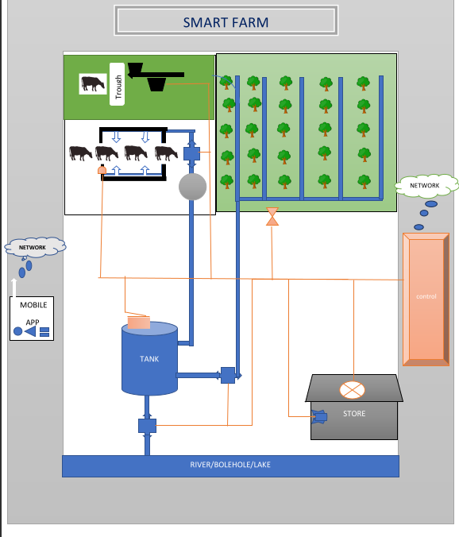

Figure 3.0.1

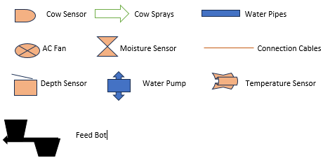

Figure 3.0.2

### **3.4.2 User Case Diagram**

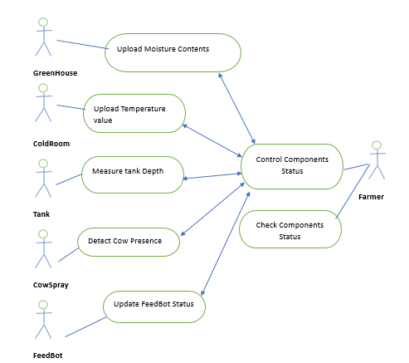

Figure 3.0.3

### **3.4.3 Context Diagram**

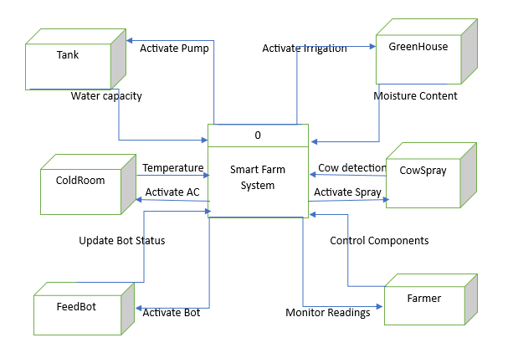

Figure 3.0.4

### **3.4.4 Data Flow Diagram**

#### **3.4.4.1 DFD LEVEL 1**

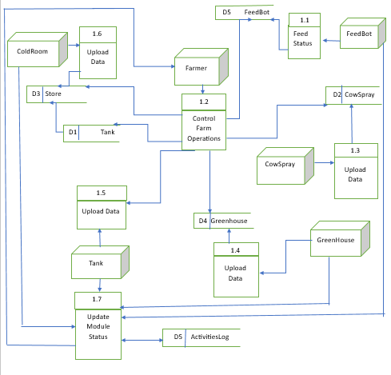

Figure 3.0.5

#### **3.4.4.2 DFD LEVEL 2**

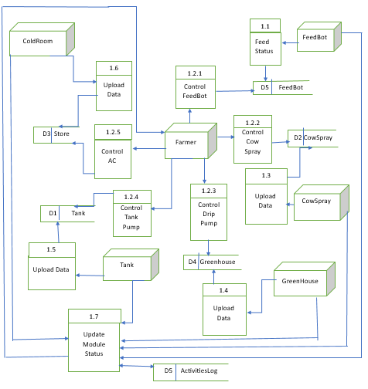

Figure 3.0.6

#### **3.4.4.3 DFD LEVEL 3**

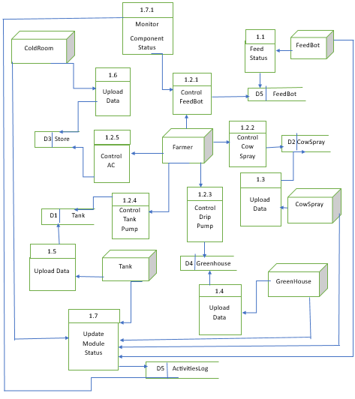

Figure 3.0.7

### **3.3.5 Class Diagram**

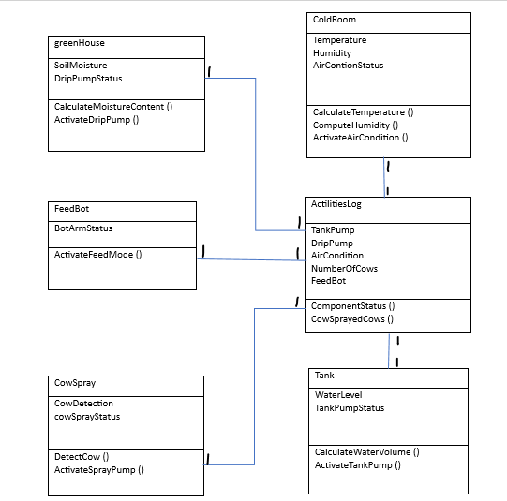

Figure 3.0.8

### **3.4.6 Entity Relationship Diagram**

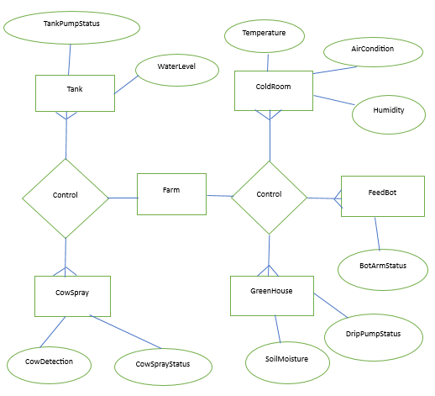

Figure 3.0.9

## **3.5 Work Plan**

The Project need task Schedule for every event this is to ensure that the project is completed at a propriate time schedule. Task will be divided into smaller fragments that can be operated on. Base on this task items duration and number of days are all stated with consideration of the number of tasks to be performed at a given stage.

## **3.6 Budget**

The project development needs a budget estimation that will enable the project to be completed successfully. The billing is required to include all aspects needed to generate the required functionality output of the project.

## **3.7 Summary**

The "System and Design Analysis" section critically examines the project's technological framework, emphasizing the fusion of computer science with agriculture's core objectives. These objectives, which encompass efficient water resource management, enhanced livestock health and hygiene, reduced labour costs, remote monitoring, and improved product preservation, are systematically tackled through the strategic deployment of technology and system design. This section underscores the transformative power of well-planned computer-based solutions, encompassing data analytics, automation, and remote monitoring tools, to revolutionize agricultural practices. The meticulous design and analysis of these systems are central to achieving the project's overarching goals, contributing to more sustainable, productive, and profitable farming operations.

# **Reference**

The Manual Sprinkler irrigation have the following features according to review of Van_der_Gulik & British Columbia Ministry of Agriculture and Fisheries. Soils and Engineering branch. 1989).

Duret, S., Hoang, H. M., Flick, D., & Laguerre, O. (2014). Experimental characterization of airflow, heat and mass transfer in a cold room filled with food products. *International journal of refrigeration*, *46*, 17-25.

Jago, J. G., Krohn, C. C., & Matthews, L. R. (1999). The influence of feeding and handling on the development of the human–animal interactions in young cattle. Applied Animal Behaviour Science, 62(2-3), 137-151.

Knapp, F. W., Henson, W. H., Panchappa, K. M., & Yeoman, O. J. (1989). Automatic control of a cattle spraying system. *Applied Engineering in Agriculture*, *5*(3), 436-438.

# **Appendix**

## **3.2 farm operations**

-hand feeding

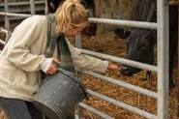

Figure 3.0.10

-Irrigation method

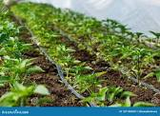

Figure 3.0.11

## **3.2 Questionnaire results**

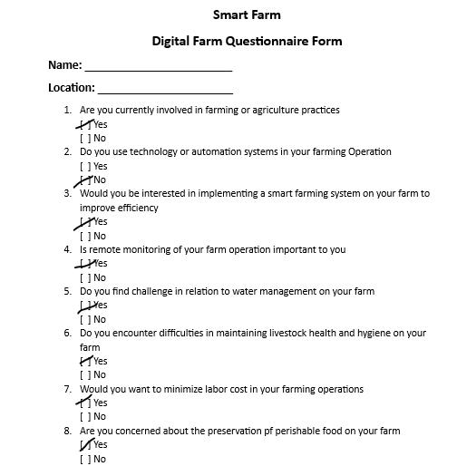

Figure 3.0.10.2

## **3.5 Gantt Chart**

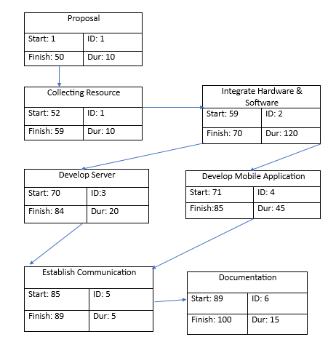

Figure 3.0.10.3

## **3.6 Budget**

Table 2

|  |  |  |  |
| --- | --- | --- | --- |
| **Items** | **Quantity** | **Unit** | **Cost** |
| **software** | **3** | **100** | **300** |
| **Untra Sonic Sensor** | **2** | **250** | **500** |
| **Temperature Sensor** | **1** | **350** | **350** |
| **Moisture Sensor** | **1** | **320** | **320** |
| **Motors** | **6** | **150** | **900** |
| **Micro Controller** | **1** | **1900** | **1700** |
| **Servo Motors** | **2** | **450** | **900** |
| **Structure** | **1** | **1500** | **1500** |
| **Total Amount** | | | **6400** |